

CSA0902-Programming in Java

CO1 - Assessment Too1-3

Ashmi.P.S
192571004

1.Sum and Average
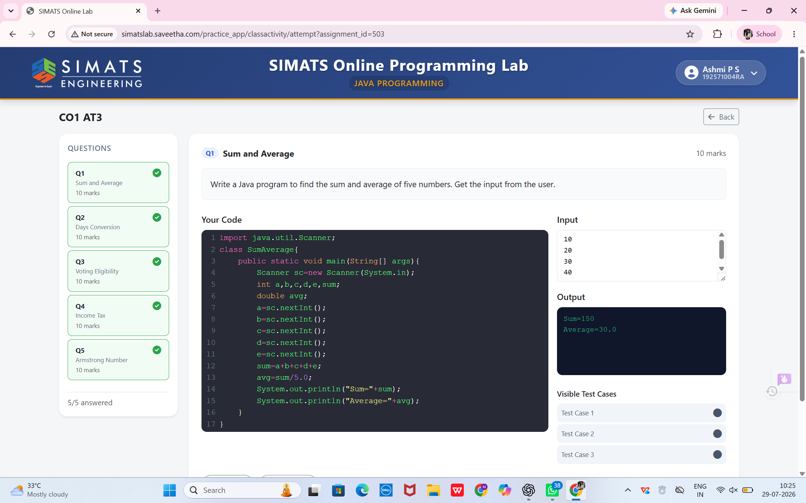

2.Days Conversion
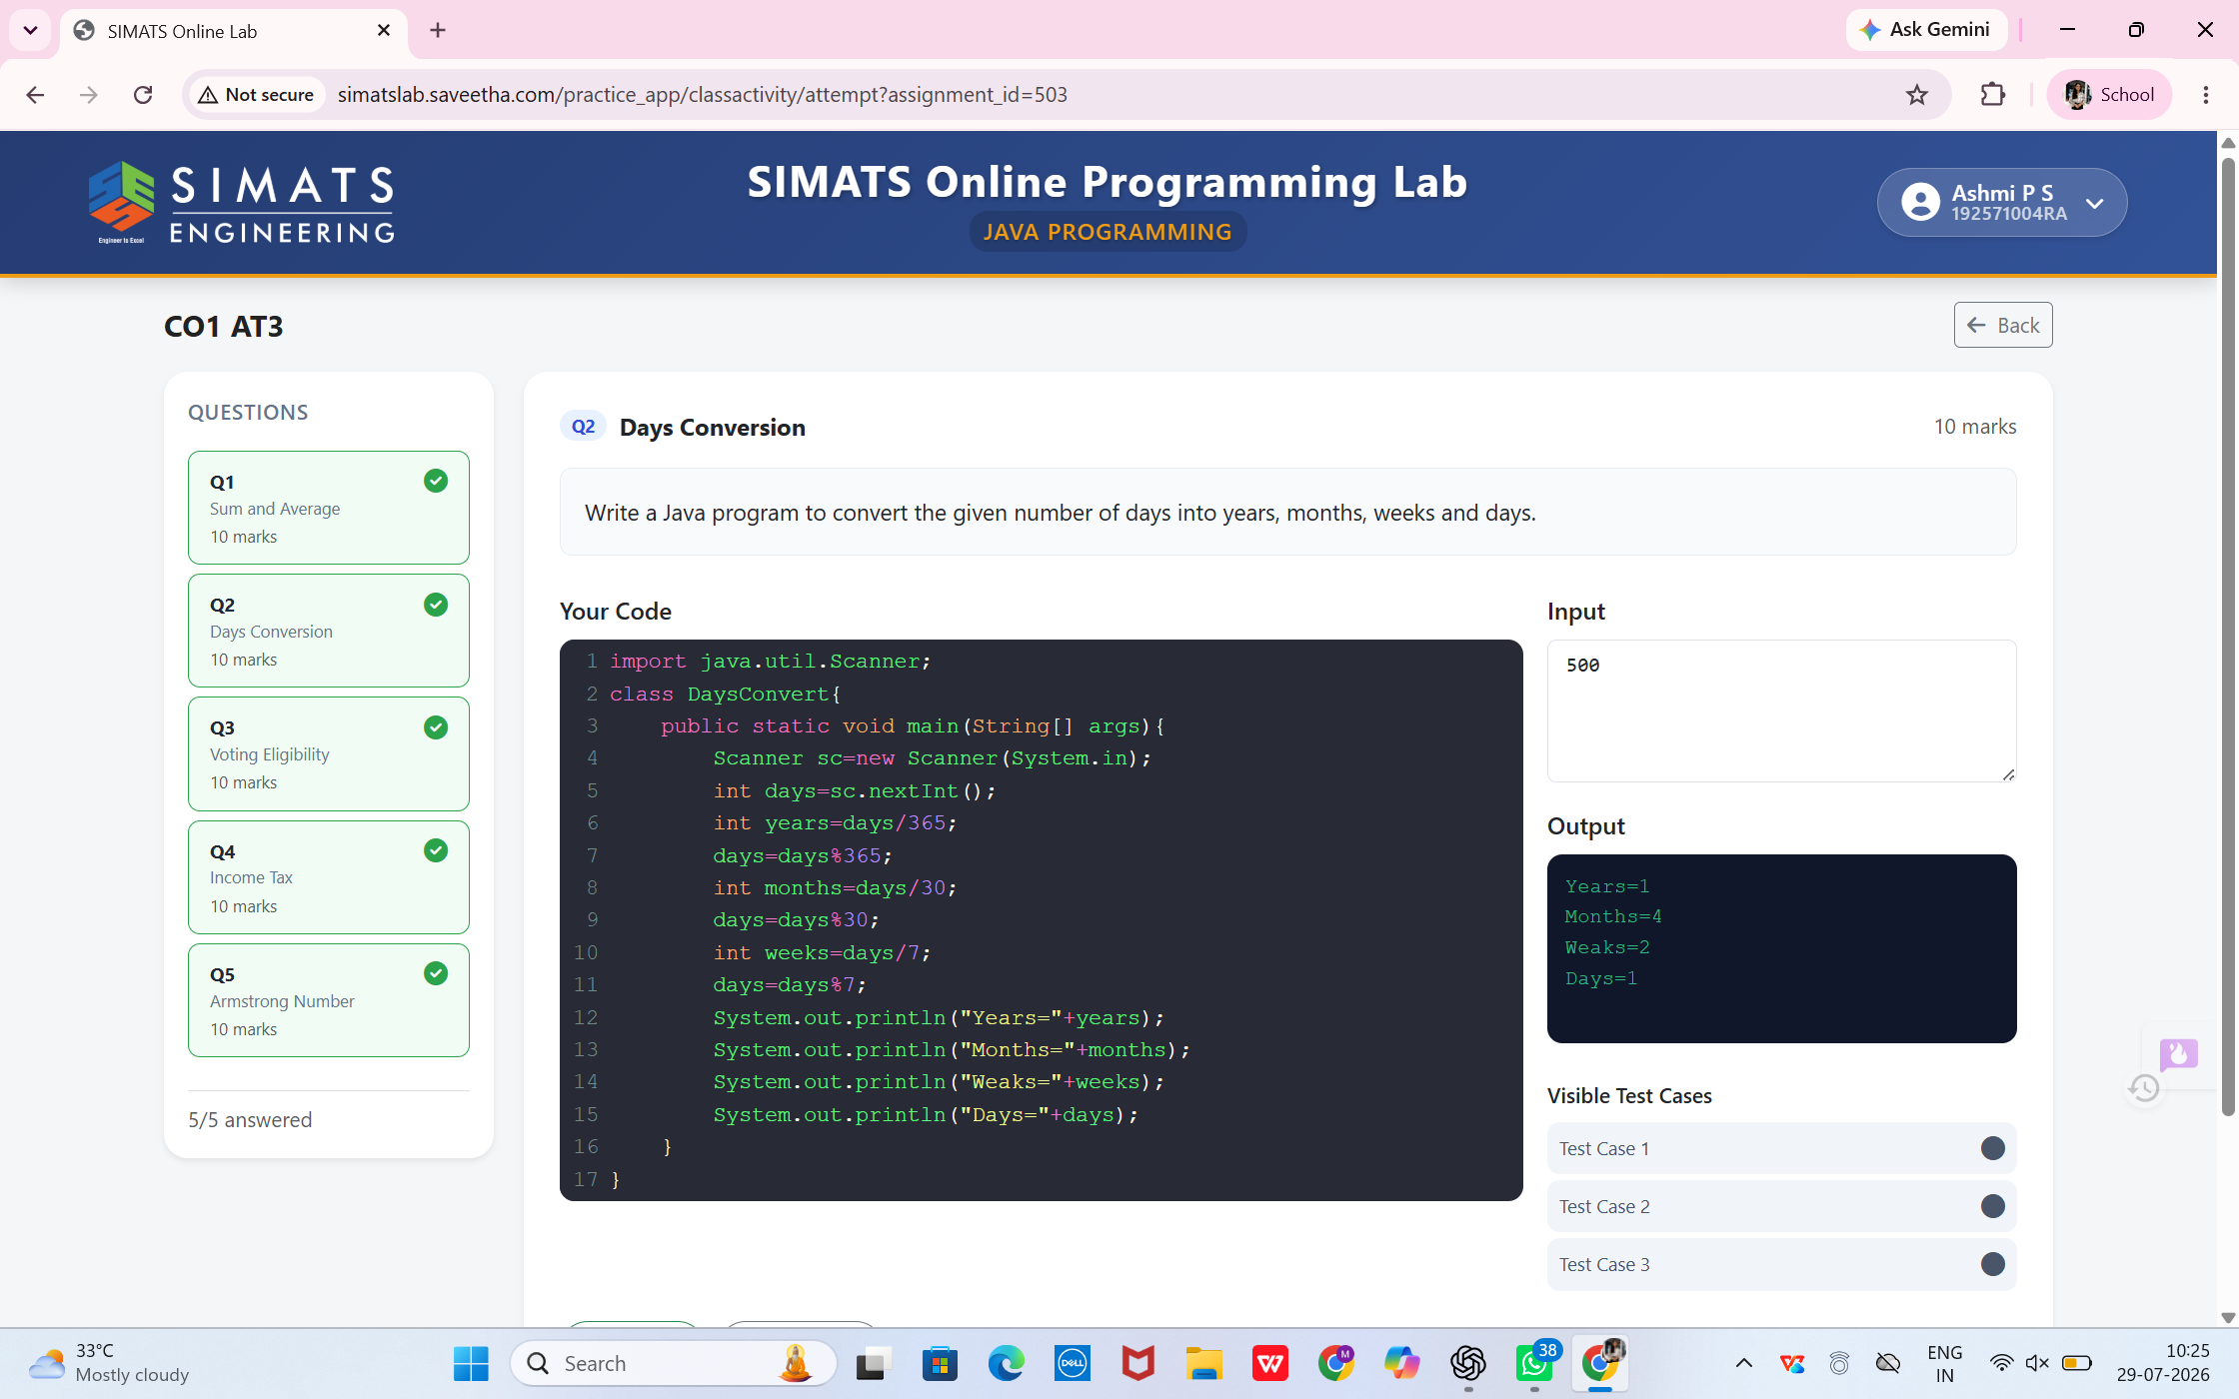

3.Voting Eligibility
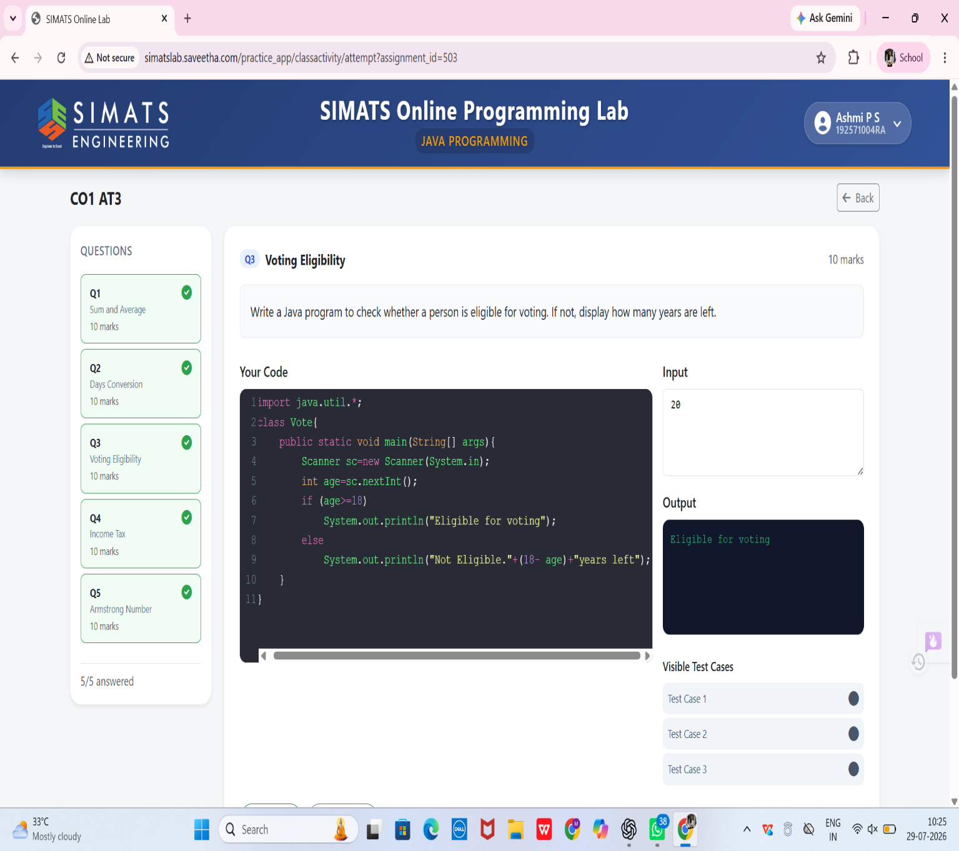

4.Income Tax
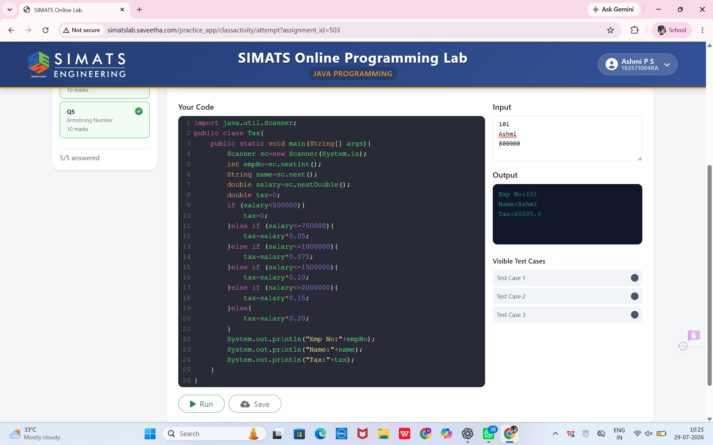

5.Armstrong Number
